labeleR: an R package to optimize the generation of collection labels and scientific documents

Julia G. de Aledo1,2,3, Jimena Mateo-Martín3, Francisco Rodríguez-Sánchez4, Ignacio Ramos-Gutiérrez3,4

1. Estación Biológica de Doñana
2. Universidad Rey Juan Carlos
3. Universidad Autónoma de Madrid
4. Universidad de Sevilla

Corresponding author*: Ignacio Ramos-Gutiérrez ([ig.ramosgutierrez@gmail.com](mailto:ig.ramosgutierrez@gmail.com))

# Keywords

R; Rmarkdown; LaTeX; scientific collections; scientific events; herbaria; automation; exams

# Summary

labeleR is an R package designed to automate the creation of documents for scientific and academic purposes. It simplifies repetitive and time-consuming tasks, offering a practical alternative to manual or costly tools. Starting from a tidy dataset, users can easily customize content, incorporate QR codes, logos, images, and edit their own templates, transforming tedious and repetitive workflows into an efficient, reproducible process. The package is available under an open-source license and can be freely downloaded from CRAN or the GitHub repository (<https://ecologyr.github.io/labeleR/>).

labeleR functions can generate a wide variety of customizable PDF documents adjusted for multiple requirements. First, there is a set of functions designed to create labels for scientific collections (e.g. labels for herbarium vouchers or insects). These functions are flexible in the information to be included, but also developed to follow a standard aspect, while allowing to incorporate custom information, such as logos or QR codes. Second, documents generated for scientific events organization, such as personal badges, abstract books, or attendance or participation certificates. These latter ones not only can be bulk rendered, but also emailed individually, avoiding the repetitive task of individual mailing or storing all certificates in a common online repository. Additionally, other-purpose resources can be rendered using labeleR, as is the case for the multiple-choice test generating function. All labeleR-generated documents have been designed with a template which we have considered to be optimal for default use. However, they can be edited to render completely customized files, specifically tailored for each individual purpose.

# Statement of need

The management and design of scientific labels and event documents is a time-consuming task. Large-scale label generation tools for herbarium and scientific collections (used by institutions such as museums or botanical gardens) are often paid and proprietary software (e.g. “BRAHMS,” 2025; “IrisBG,” 2024). Microsoft Excel-Word integration through mailing lists is commonly used at a smaller scale, although still involving paid software with limited large database management capacity. Most free alternatives are not open-source, require installing a program with limited customization, and are often only compatible with Windows operating system (e.g. Pando, Lujano, & Cezón, 2019; “pLabel,” 2020), or designed for very specific purposes (e.g. “EntomoLabels” (2022) for insects, “LichenLabeler” (2025) for lichens or Zhang, Zhu, Liu, & Fischer (2016) for plant vouchers). Additionally, credentials and certificates for scientific events —as well as any other event such as workshops, seminars, or conferences— are either created manually one at a time, through paid online servers, or by hiring an event organization company. These approaches are often costly, inflexible, or require technical expertise. To our knowledge, there are no free, customizable tools for the bulk production and distribution of these documents. labeleR fills this gap facilitating the creation of scientific collection labels, conference badges, attendance and participation certificates, and abstract books, among others. Additionally, individual certificates can be automatically and individually delivered by email if desired. Therefore, labeleR is designed to be used not only by scientists, but also by educators, event organizers, and institutions of any kind, regardless of their technical background.

# Package description

The labeleR package builds upon the RMarkdown ecosystem (Allaire et al., 2024) to generate PDF documents from a tidy data frame in R (Figure 1). labeleR functions include three types of arguments: (1) R instructions, such as the data object, paths and file name of the rendered document; (2) “fixed” arguments, text that remains constant across output documents (e.g. event name or image path); (3) “variable” arguments, linked to columns in the dataframe, thus changing between documents (e.g. taxonomic names in labels or attendee names in certificates). A QR code can be included either through a fixed argument or a variable argument, without the need for external software, only by providing the link. Users can also edit and adapt the default RMarkdown templates (such as fixed text, font size or face, order in which fields appear, image size and position…) provided by the package for their own purposes. Details on template customization, among other common issues, are detailed in the package website’s FAQ section.

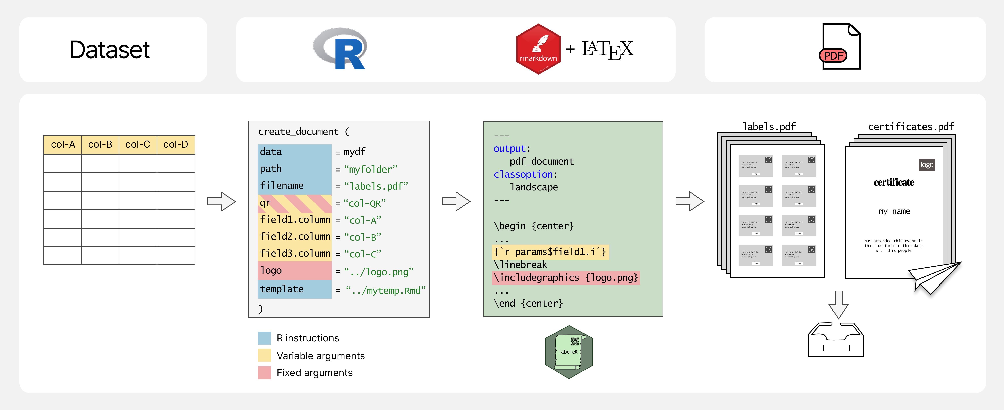

Figure 1. labeleR package workflow. Information stored in a dataset passes through an R function into a parameterized RMarkdown file using LaTeX syntax, and is then rendered as PDF. labeleR functions accept three argument types: R instructions which specify the dataset, paths to images or add custom templates (in blue); fixed arguments, such as titles or subtitles (in red), and variable arguments, linked to columns of the dataset (in yellow). Users work directly on R to introduce the parameters, while labeleR works in the background with markdown and latex to produce the results. Output PDF documents can be automatically emailed to participants.

# Types of documents that can be generated with labeleR

## Labels for collections

Appropriate labelling of samples is a fundamental step of the scientific process (i.e., labelling test tubes in laboratories, storing animal or plant materials or displaying collections in museums or botanical gardens). A user-friendly bulk rendering tool is vital for efficiently producing crafted, uniform labels in a reproducible manner. We present three label types: “herbarium” (most complex), “collection” (most aesthetic) and “tinylabels” (compact and simplified, for example, for insect collections or lab tubes) (Figure 2). These labels can include QR codes (e.g. links to websites, images, or identification codes) without additional tools, making it easy to quickly access and link to external information.

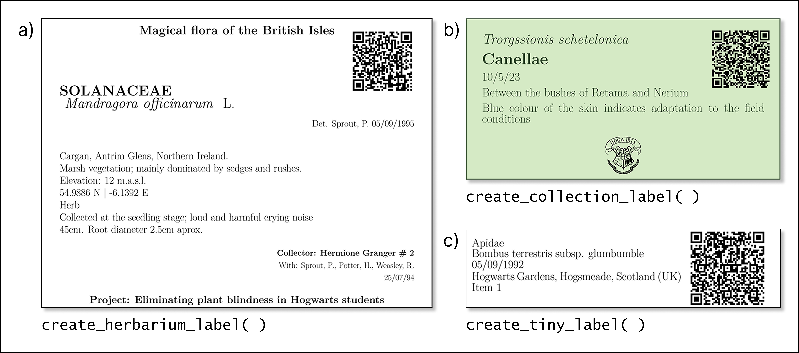

Figure 2. Examples of the outcomes from each label-related function in labeleR. a) Herbarium label: for stored plant vouchers; includes fixed fields (title, subtitle) and variable fields (e.g. taxon, date, coordinates, elevation). The family field is by default capitalized and bold, and species name italic. Size: 4 labels/page. b) Collection label: includes variable fields (first field in italics, second in bold), a customizable logo, font and background colors. Size: 8/page. c) Tinylabel: a simplified collection label with five fields. Size: 16/page. All three functions can include an optional QR code.

## Documents for scientific events

Scientific events often host a high number of participants, and require the creation of identification badges, abstract books and certificates for attendees and participants (Figure 3). With labeleR, templates and code can be customized according to the event, and bulk rendering significantly decreases the amount of time invested in the creation of such materials. Manually delivering attendance and participation certificates is highly time-consuming, but labeleR functions allow users to automatically send individual documents to email addresses stored in a column.

# Further applications

The labeleR philosophy is quite simple: creating multiple documents with a common design from a dataset containing the required information. It offers a modular structure that allows for customization and extension for new applications. For instance, the newly added create_multichoice( ) function generates multichoice tests randomizing the order of questions and possible answers from a table including a set of questions. New developments will happen in the GitHub repository (<https://github.com/EcologyR/labeleR>) and eventually pushed to CRAN.

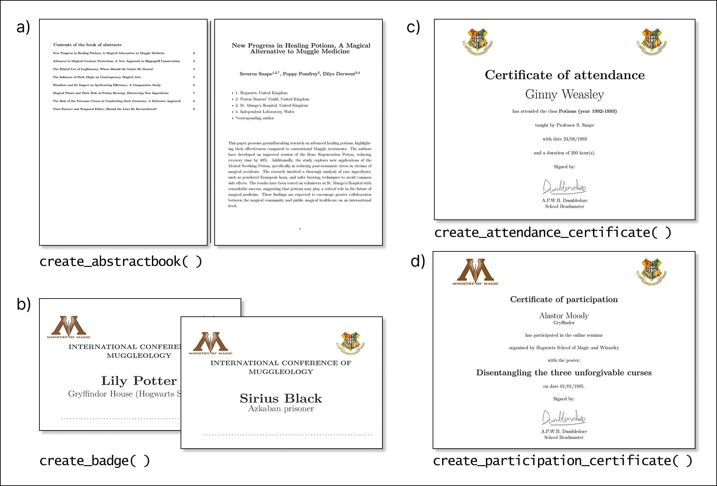

Figure 3. Examples of outcomes from each event-related function in labeleR. a) Abstract book: creates pages with title, authors, affiliations and abstract (variable fields) and can include a table of contents and front page. b) Badges: include name, affiliation, a fixed field for the title, the option to add two images on top, and a dashed line at the bottom for additional hand-written information. c) Attendance certificate: attendee name is a variable field, while event name, signer, and date are fixed fields. d) Participation certificate: includes name, affiliation and title of the communication, and several fixed fields. Both certificate functions allow two images on top, a signature at the bottom, and offer Spanish and English templates.

# Acknowledgements

This package has been developed collaboratively between Sevilla and Madrid, with continuous feedback from colleagues in both locations. We acknowledge their input, support and collaboration. We are especially grateful to Manuel Molina for his ideas at labeleR initial stages. We would like to emphasize that the original idea has been built horizontally among early career researchers. Our work has been possible thanks to the support of the institutions and projects that employ us, and especially by the software-developing workshop (Cádiz, La Muela, 2023) organized by AEET and funded by US-1381388 grant from Universidad de Sevilla/Junta de Andalucía/FEDER-UE.

J.G.A. was supported by Next Generation EU Investigo contract (URJC-AI-17) and ANTENNA Biodiversa+ and European Commission (PCI2023-146022-2) postdoctoral contract. J.M.M. was supported by the Comunidad de Madrid and Universidad Autónoma de Madrid doctoral grant PEJ-2020-AI/AMB-17551 and research assistant contract PIPF-2022/ECO-24251. F.R.S. was supported by VI PPIT-US and grants US-1381388 from Universidad de Sevilla/Junta de Andalucía/FEDER-UE and CNS2022-135839 funded by MICIU/AEI/10.13039/501100011033 and by European Union NextGenerationEU/PRTR. I.R.G. was supported by a doctoral grant at Universidad Autónoma de Madrid and a postdoctoral position at Universidad de Sevilla (CNS2022-135839).

# References

Allaire, J., Xie, Y., Dervieux, C., McPherson, J., Luraschi, J., Ushey, K., Atkins, A., et al. (2024). *Rmarkdown: Dynamic documents for r*. Retrieved from <https://github.com/rstudio/rmarkdown>

BRAHMS. (2025). Retrieved from <https://herbaria.plants.ox.ac.uk/bol/brahms>

EntomoLabels. (2022). Retrieved from <https://labels.entomo.pl/>

IrisBG. (2024). Retrieved from <https://www.irisbg.com>

LichenLabeler. (2025). Retrieved from <https://lichenportal.org/>

Pando, F., Lujano, C., & Cezón, K. (2019). Elysia: Programa de gestión de colecciones de biodiversidad (v.2.0). Digital.CSIC. doi:[10.20350/DIGITALCSIC/14520](https://doi.org/10.20350/DIGITALCSIC/14520)

pLabel. (2020). Retrieved from <http://pfind.net/software/pLabel/index.html>

Zhang, J., Zhu, H., Liu, J., & Fischer, G. A. (2016). Principles behind designing herbarium specimen labels and the R package ’herblabel’. *Biodiversity Science*, *24*(12), 1345–1352.